APPLIED DATA SCIENCE ASSIGNMENT 1

NAME: Rani Panneru

STUDENT NUMBER: 22077318

COURSE: MSC in Data science with placement year

DATA VISUALISATION

Data source and variables:

This visualization relies on data sourced from the World Bank's data repository.

The focal point of this analysis is the 'Share of Renewable Energy Consumption (% of Total Consumption Over Time), 'categorized by various countries. The dataset

encompasses the years 1998-2020, facilitating a comparative assessment of

renewable energy consumption among nations over a decade.

VISUALIZATION_1

LINE PLOT:

Line plot is a type of data visualization that displays data points over a continuous interval, typically along a time axis. Line plots are used to illustrate trends, changes, or patterns in data over a specific period.

At present line plot is describing renewable energy consumption over time would typically involve having data points for renewable energy consumption at different time intervals.

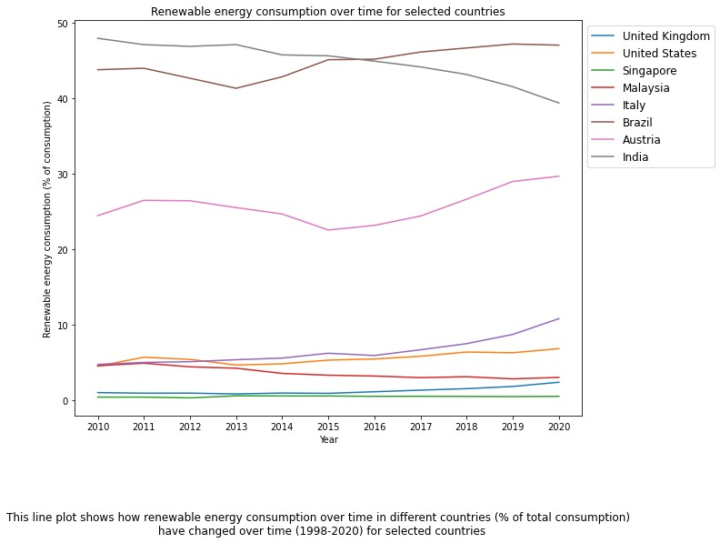

Description

The line graph clearly explaining the trends of the level of renewable energy consumption among different countries from the period of 10 years (2010_2020)

Singapore was with no progressive changes in consumption level of renewable energy for continuous 10 years with less than 5% of energy consumption.

United Kingdom is also more or less like Singapore with less than 5% over 10 years of time but from 2018 United Kingdom started trying for the change to consume renewable energy sources where the line is slightly raised from 2018 to 2020. The same had applied in case of Malaysia, Italy and united states.

Moreover, Austria had made progressive growth in consuming the renewable energy with more than 25% over 10 years of time period.

However, India and Brazil are in highest position in consuming the renewable energy sources but India made a back step since 2015 and fall down from 48% to 40% but Brazil was increasing constantly and was in lead over other countries with almost 49% in 2020.

However highest percentage of consumption of renewable energy is made by Brazil and India when compared with other countries in 2005 and the least by Singapore and United Kingdom.

CONCLUSION:

These percentages provide insights into the extent to which each country utilized renewable energy sources in their energy consumption during the specified year. The data reflects the varying levels of commitment and investment in renewable energy across different nations.

VISUALIZATION_2

BAR PLOT:

Bar plot is a graphical representation of data using rectangular bars or columns. Bar plots are commonly used in data visualization to display and compare data in different categories or groups.

Why I selected Bar plot?

I selected bar graph as my third choice for analysing the data the data (“renewable energy consumption in the year 2020”) through visualization because a bar plot can be a good choice for visualizing renewable energy consumption in the year 2020, especially when comparing different sources or making simple year-to-year comparisons. However, the "best" choice of visualization depends on the nature of your data

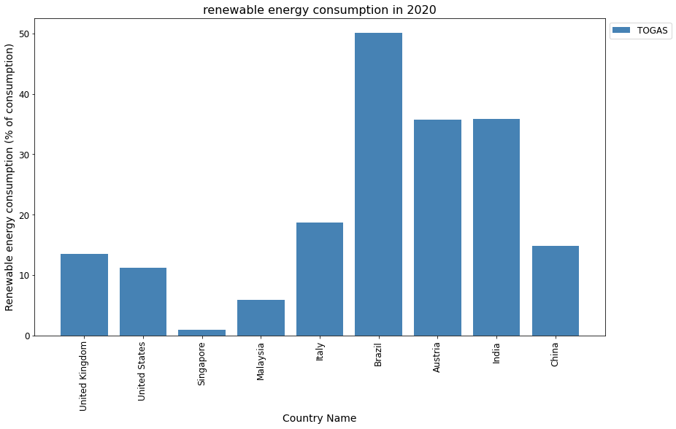

DESCRIPTION:

The bar graph shows the renewable energy consumption in 2020 for various countries. Renewable energy is the energy that comes from natural sources such as wind, solar, hydro, biomass, and geothermal. The percentage of renewable energy consumption indicates how much of the total energy consumption in a country is from renewable sources.

According to the bar graph, the country with the highest renewable energy consumption in 2020 was TOGAS, with 50%. This means that half of the energy used in TOGAS came from renewable sources. The country with the lowest renewable energy consumption was Singapore, with only 2%. This means that only 2% of the energy used in Singapore came from renewable sources.

The bar graph also shows that China and India had high renewable energy consumption, with 38% and 36% respectively. These two countries are among the largest and most populous in the world, and they have been investing heavily in renewable energy projects in recent years. On the other hand, the United States and the United Kingdom had low renewable energy consumption, with 11% and 12% respectively. These two countries are among the wealthiest and most developed in the world, but they have been relying mostly on fossil fuels for their energy needs.

The bar graph can help us compare and contrast the renewable energy consumption of different countries, and understand the factors that influence their energy choices. Renewable energy is important for reducing greenhouse gas emissions, combating climate change, and ensuring a sustainable future for the planet.

Conclusion:

However, the highest renewable energy consumption was made by Brazil and the least was by Singapore.

These percentages provide insights into the extent to which each country utilized renewable energy sources in their energy consumption during the specified year 2020. The data reflects the varying levels of commitment and investment in renewable energy across different nations.

VISUALIZATION_3

PIE PLOT:

Pie plot is a circular graphical representation used to display data as a whole and show how individual parts contribute to the whole. It is a common type of chart used in data visualization technique.

Why I selected Pie plot?

A pie chart is well-suited for the provided example due to the specific nature of the data, which involves showing the distribution of renewable energy consumption among different countries in a single year (1998).

This pie chart illustrates the distribution of renewable energy consumption among various countries in the year 1998. The entire consumption is subdivided into segments within the chart, with each segment representing a specific country. The labels for each country are provided within the chart, along with the corresponding percentage of renewable energy consumption adjacent to its respective segment.

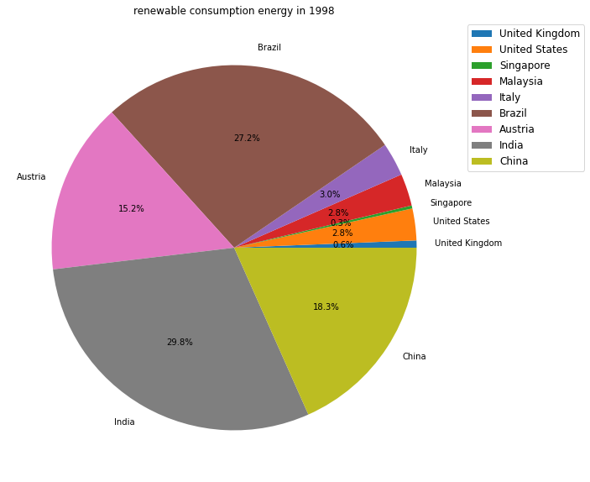

DESCRIPTION FOR PIE PLOT_1

The most substantial portions of the pie chart belong to India and Brazil, each accounting for just over 25% of the total renewable energy consumption in 1998. Following closely behind are Austria, contributing 15.2%, and China, with a share of 18.3%. The remaining countries each made a comparatively smaller contribution, each representing less than 3% of the total renewable energy consumption.

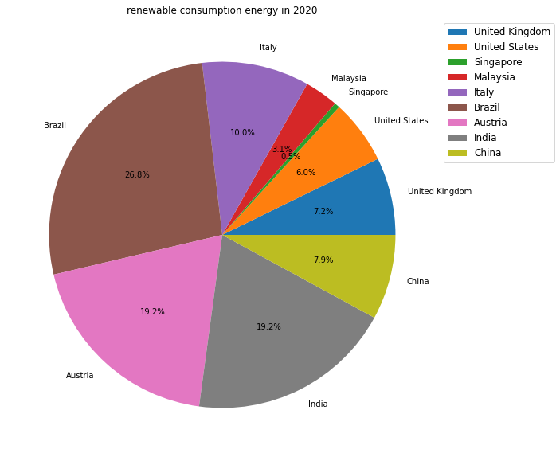

DESCRIPTION FOR PIE PLOT_2

The chart shows that Brazil had the highest share of renewable energy consumption, followed closely by India, both at 19.2%. Austria also had a significant share at 19.2%. The United States and China each contributed 6.0% and 7.9%, respectively, while Italy, the United Kingdom, Malaysia, and Singapore had smaller proportions of renewable energy consumption.

This data underscores the varying degrees of adoption of renewable energy sources across different countries, with some nation leading in sustainable energy consumption while others have a relatively smaller footprint.

**Repository: https://github.com/RaniPanneru/ads1-assignment**